Name: Zecheng GAN

Assistant professor of Advanced Materials and Mathematics (affiliate)

Email: [zechenggan@ust.hk](mailto:zechenggan@ust.hk)

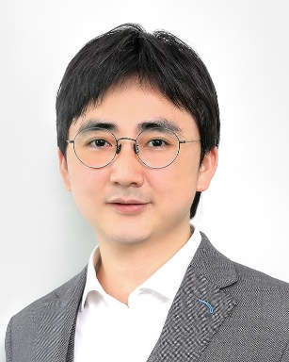

Research interest:

Prof. Gan’s research interests are on applied math and scientific computing, specifically for problems arise from advanced materials, soft matter physics, and biology. His previous research focuses on the efficient representation and algorithmic optimization for many-body interacting particle systems, and methods for partial differential equations. More recently, he is also working on data-driven and machine Learning methods for Science & Engineering.

Biography:

Prof. Gan is an Assistant Professor in the advanced materials thrust at HKUST（GZ）and affiliate assistant professor in the department of mathematics at HKUST (CWB). He received his Bachelor and PhD in mathematics both from Shanghai Jiao Tong University. Before joining HKUST in 2021, he worked at University of Michigan (2016-2019) and New York University (2019-2021), both in mathematics. His research works have been published in top peer-reviewed math/physics journals including Physical Review Letters, SIAM Journal on Scientific Computing, Journal of Chemical Physics and Journal of Computational Physics, etc. One of his work has been selected as J. Chem. Phys. Editor’s collection 2019.